**Blockchain documentation**

Hyperledger Fabric – FabAgriFund on IBM Blockchain Platform

This project involves setting up a network on the IBM Blockchain Platform and deploying the FabAgriFund smart contract. Next, we setup our application to interact with the network including identities to submit transactions on the smart contract. The application is setup with a Node.js server using the Fabric Node SDK to process requests to the network, and an Angular client to bring up a web interface.

The main steps are:

* Setup a Hyperledger Fabric network on IBM Blockchain Platform
* Install and instantiate smart contract through the IBM Blockchain Platform
* Develop an Node.js server with the Hyperledger Fabric SDK to interact with the deployed network
* Create an Angular frontend for the web app to interface with the network.

We used IBM Blockchain Platform Extension for VS Code to:

1. The Blockchain Operator sets up the IBM Blockchain Platform service
2. The IBM Blockchain Platform enables to create a Hyperledger Fabric network onto a IBM Kubernetes Service, allowing to install and instantiate the FabAgriFund smart contract on the network
3. The Node.js application server uses the Fabric sdk to interact with the deployed network on IBM Blockchain Platform and creates APIs for a web client
4. The Angular client uses the Node.js application API to interact with the network
5. The User interacts with the FabAgriFund Angular web interface to update and query the blockchain ledger and state

**Components included:**

* [IBM Blockchain Platform](https://console.bluemix.net/docs/services/blockchain/howto/ibp-v2-deploy-iks.html" \l "ibp-v2-deploy-iks) gives you total control of your blockchain network with a user interface that can simplify and accelerate your journey to deploy and manage blockchain components on the IBM Cloud Kubernetes Service.
* [IBM Cloud Kubernetes Service](https://www.ibm.com/cloud/container-service) creates a cluster of compute hosts and deploys highly available containers. A Kubernetes cluster lets you securely manage the resources that you need to quickly deploy, update, and scale applications.
* [IBM Blockchain Platform Extension for VS Code](https://marketplace.visualstudio.com/items?itemName=IBMBlockchain.ibm-blockchain-platform) is designed to assist users in developing, testing, and deploying smart contracts -- including connecting to Hyperledger Fabric environments.

### Prerequisites

* [IBM Cloud account](https://cloud.ibm.com/registration/?target=%2Fdashboard%2Fapps)
* [Node v8.x or greater and npm v5.x or greater](https://nodejs.org/en/download/)
* [VSCode version 1.26 or greater](https://code.visualstudio.com/)
* [IBM Blockchain Platform Extension for VSCode](https://marketplace.visualstudio.com/items?itemName=IBMBlockchain.ibm-blockchain-platform)

Steps followed to setup the application:

* Created IBM Cloud Kubernetes service.

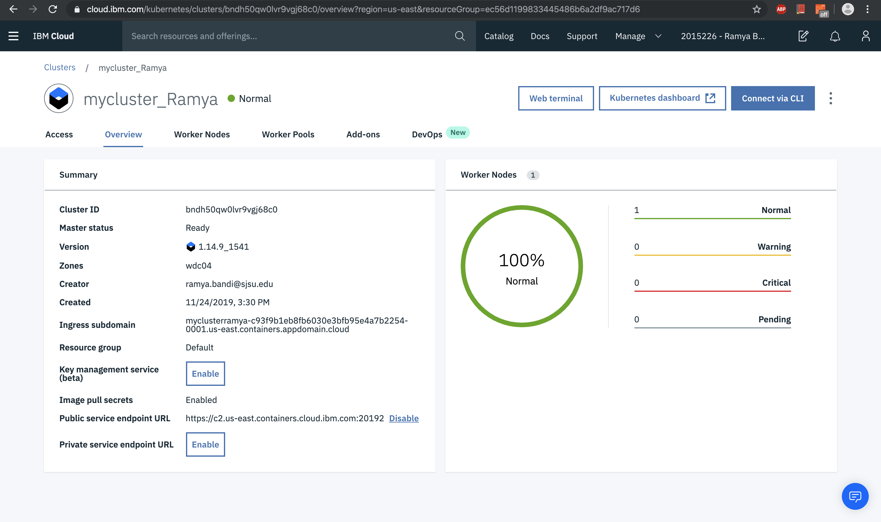

* Created the IBM Blockchain Platform service on the IBM Cloud.

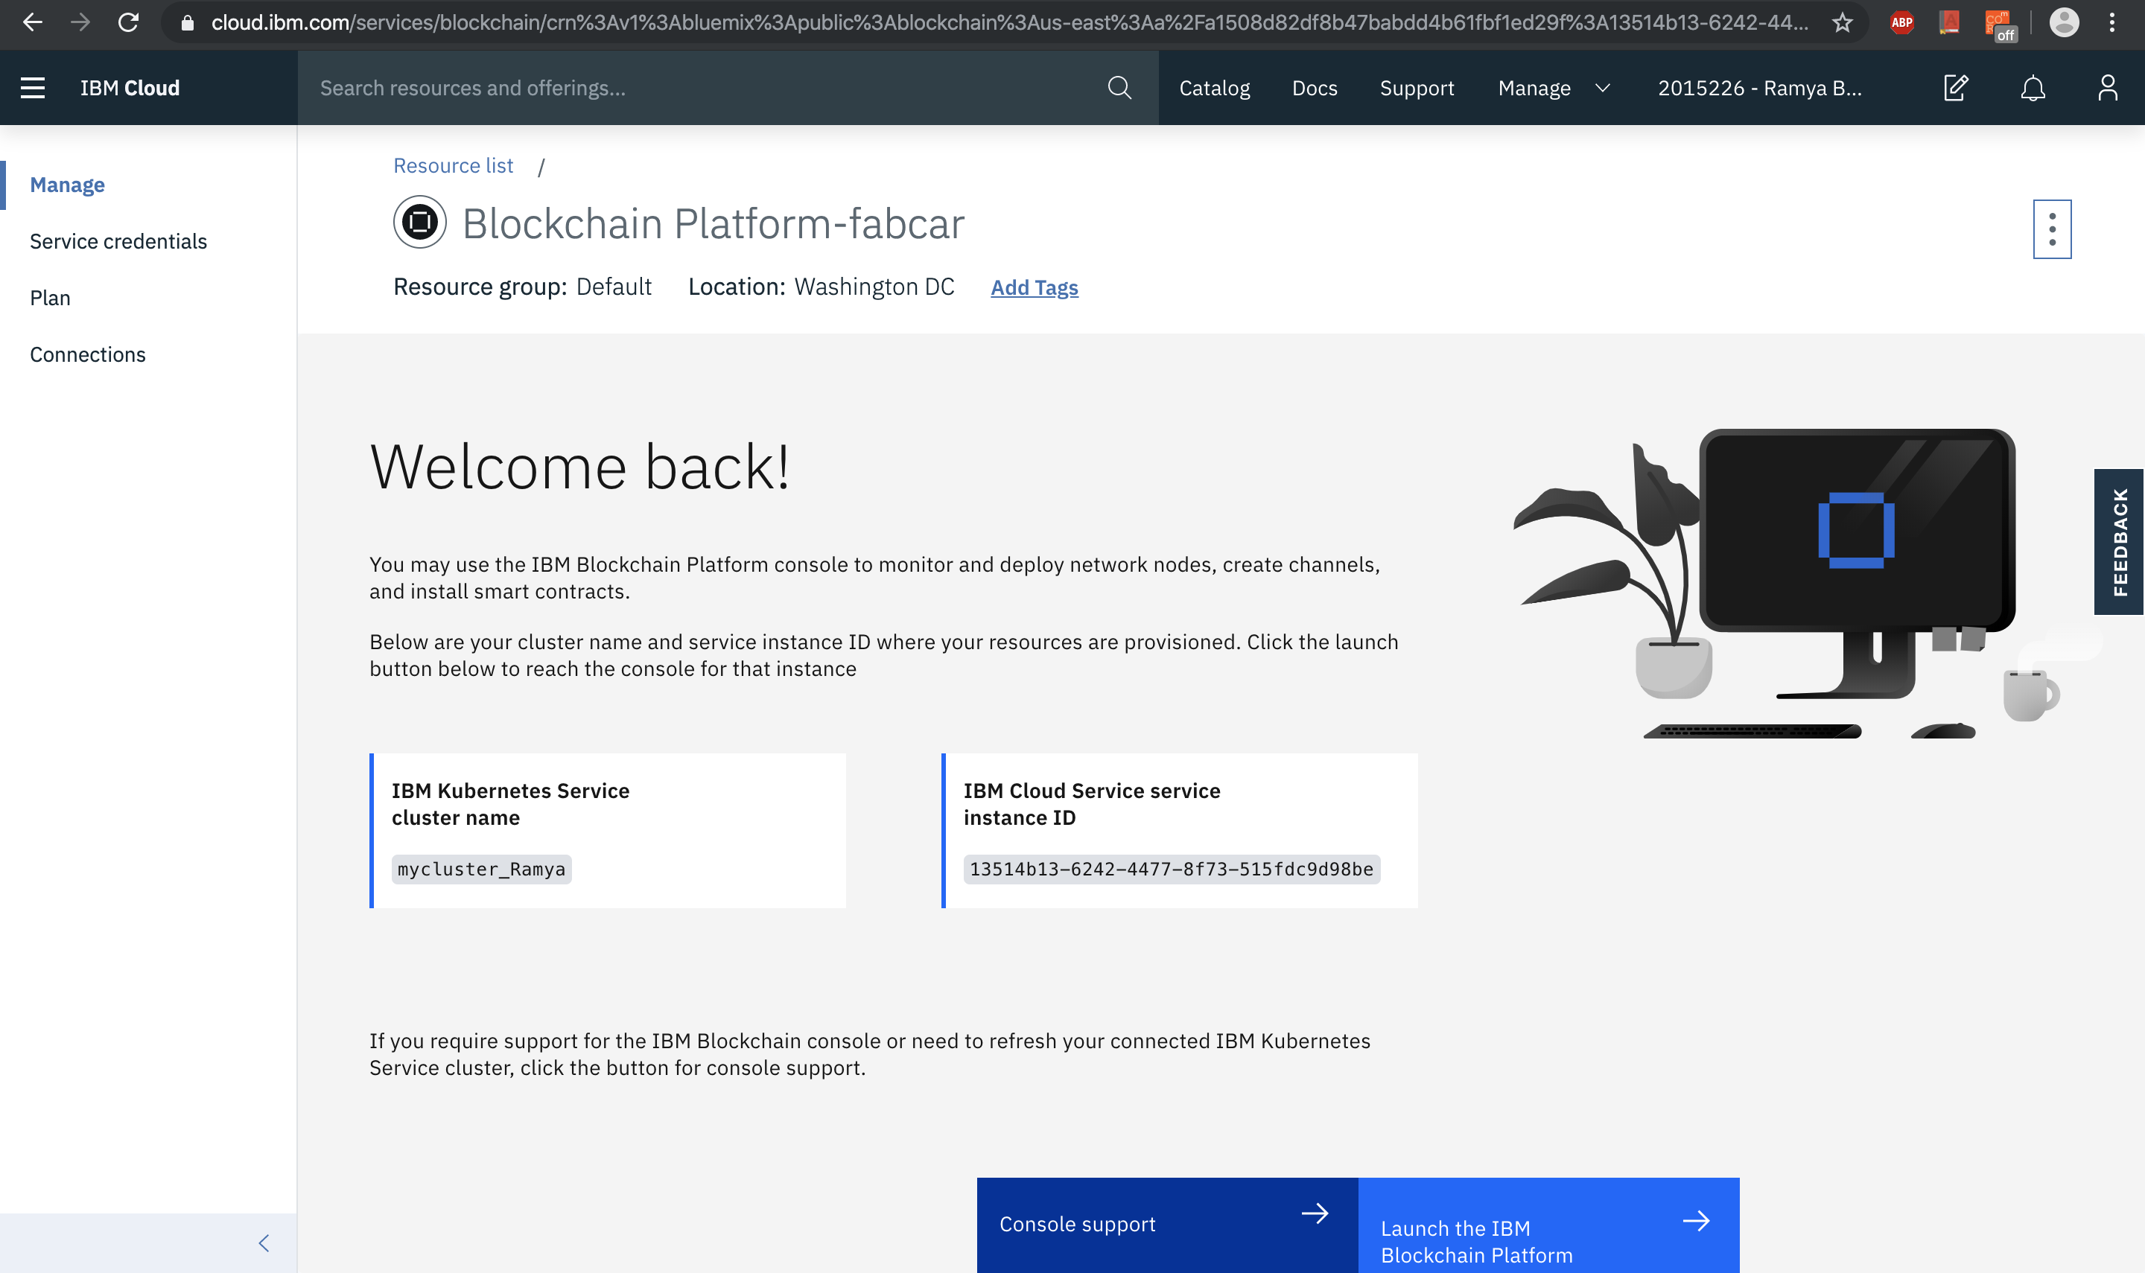

* After the Kubernetes cluster is up and running, we deployed IBM Blockchain Platform on the cluster.
* Once the Blockchain Platform is deployed on the Kubernetes cluster, we launched the console to start operating on our blockchain network.

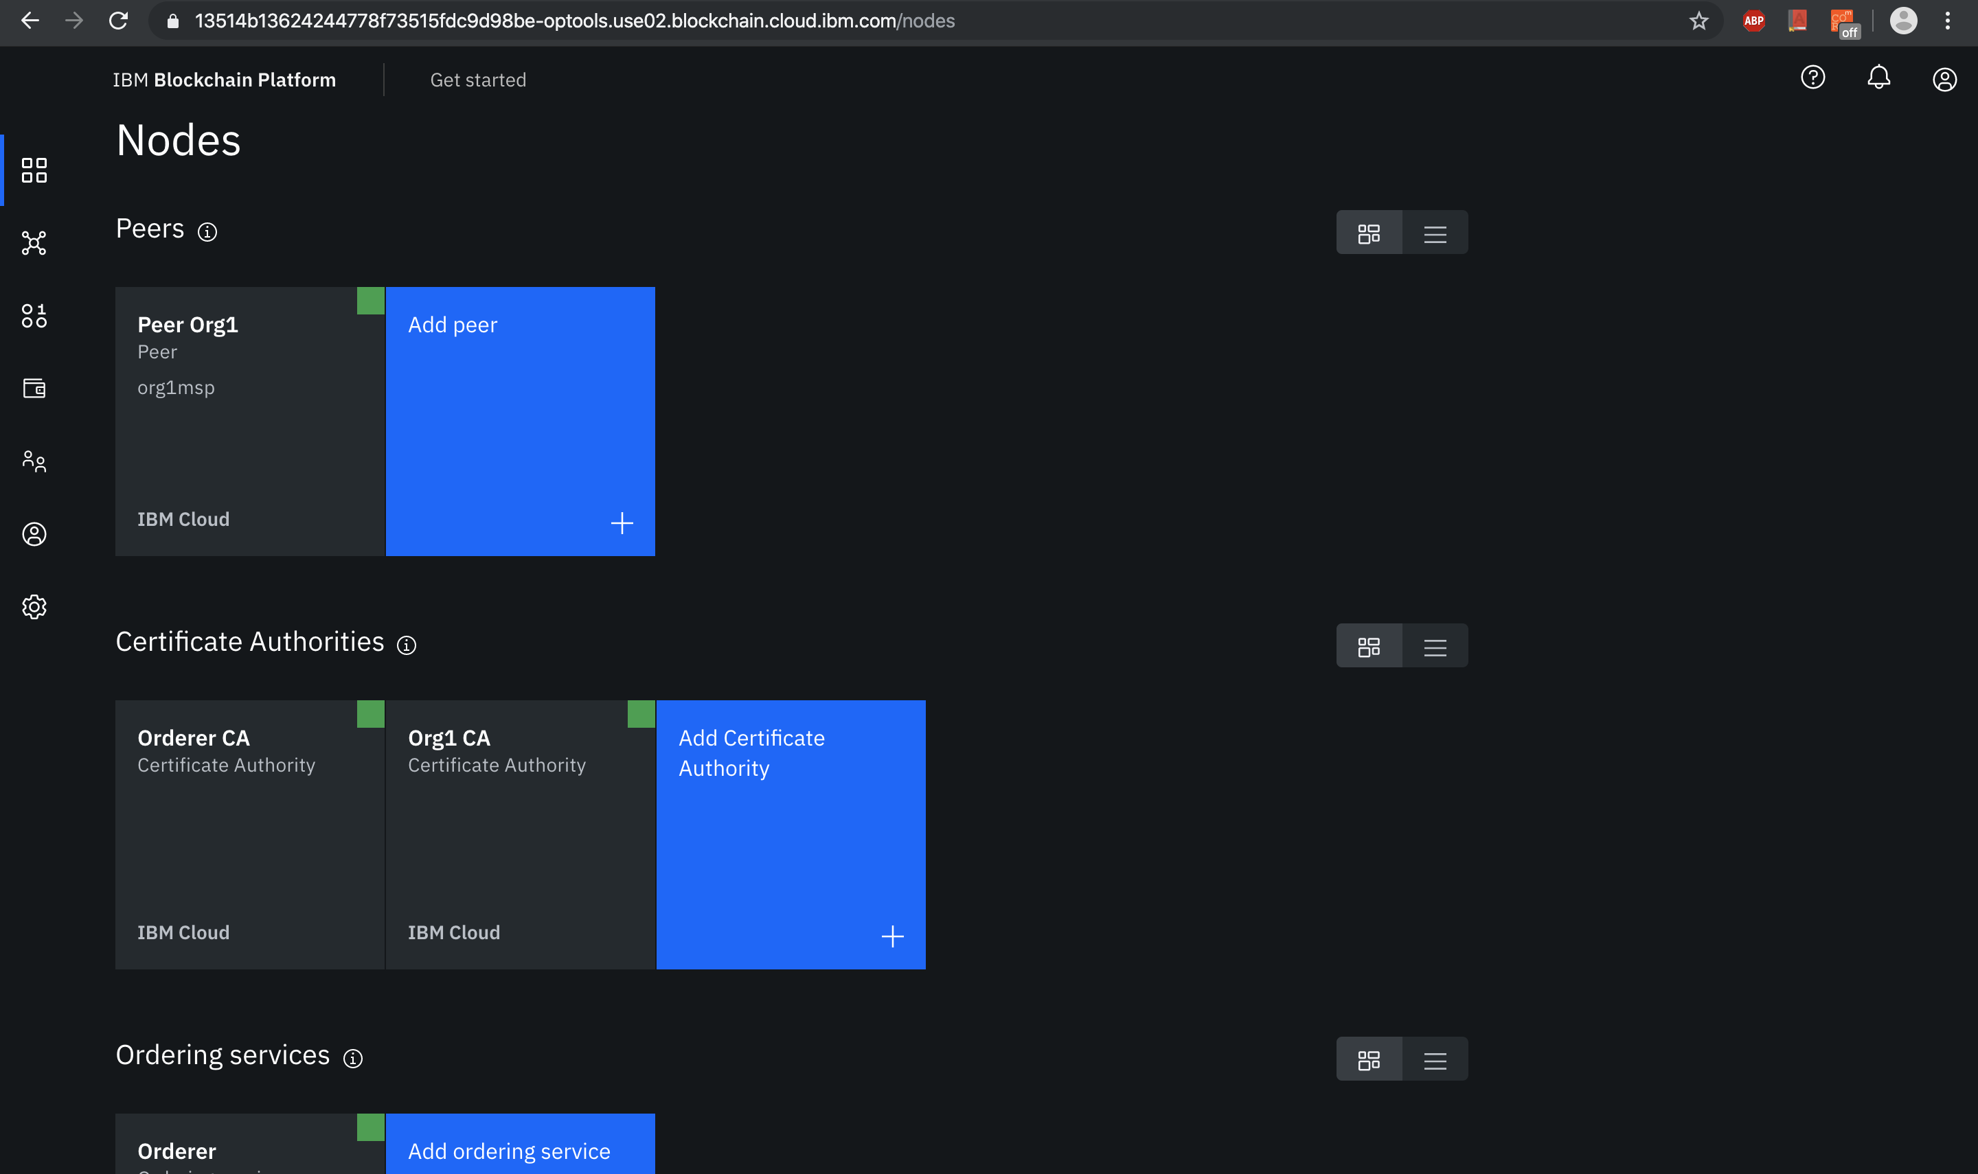

* We built a network which includes a channel with a single peer organization with its own MSP (Membership Service Providers) and CA (Certificate Authority. And then we created respective identities to deploy peers and operate nodes.
* Created Certificate Authority for peer organization

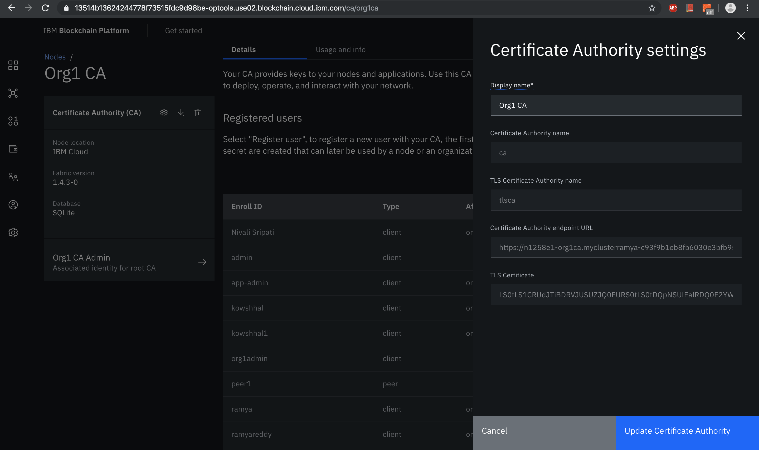

* Registered the identities using the above CA

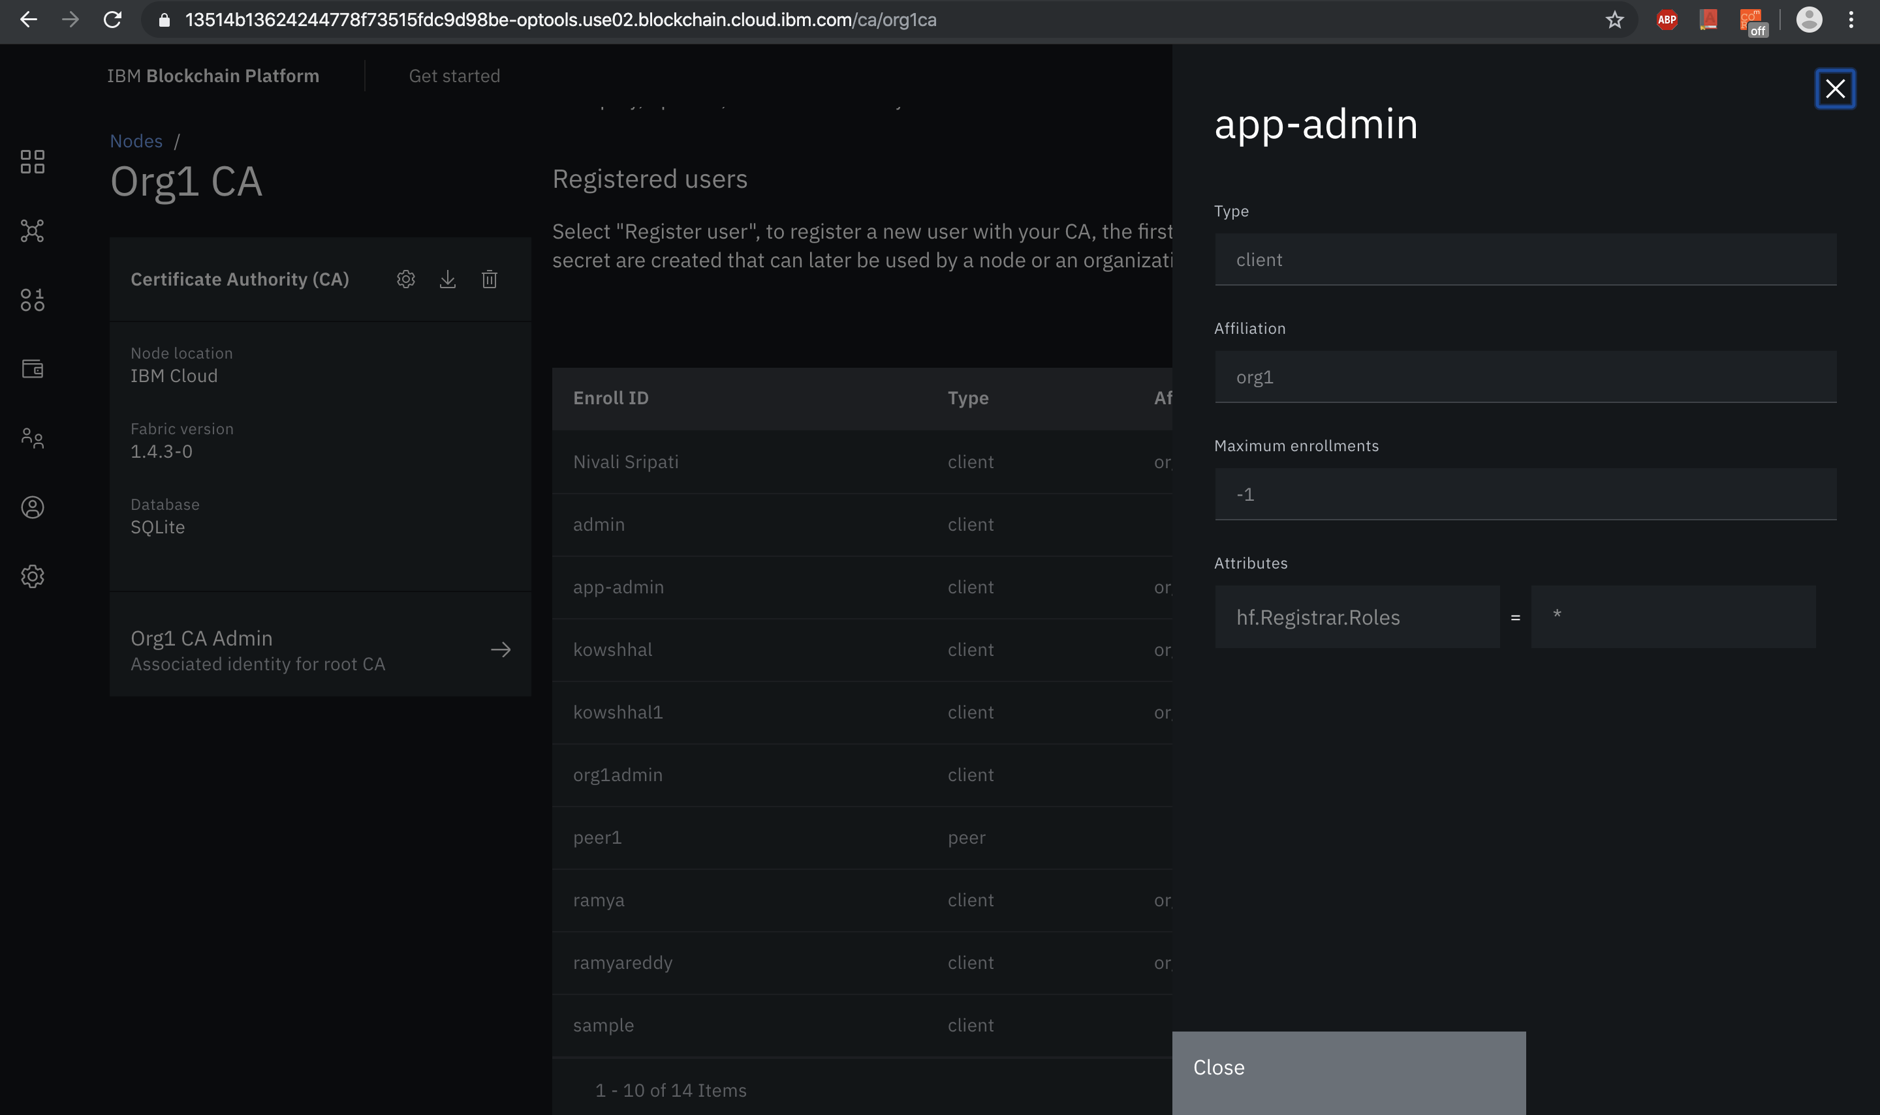

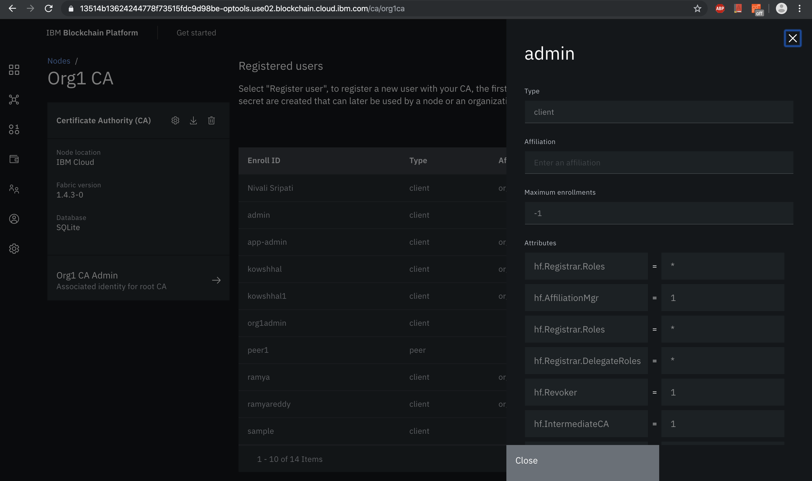

* We can register any number of users for the organization. An API call is made such that any user (farmer or donor) who signups for the AgriFund application will be auto registered into the blockchain platform so that they can submit transactions to the blockchain.
* Created the peer organization MSP definition

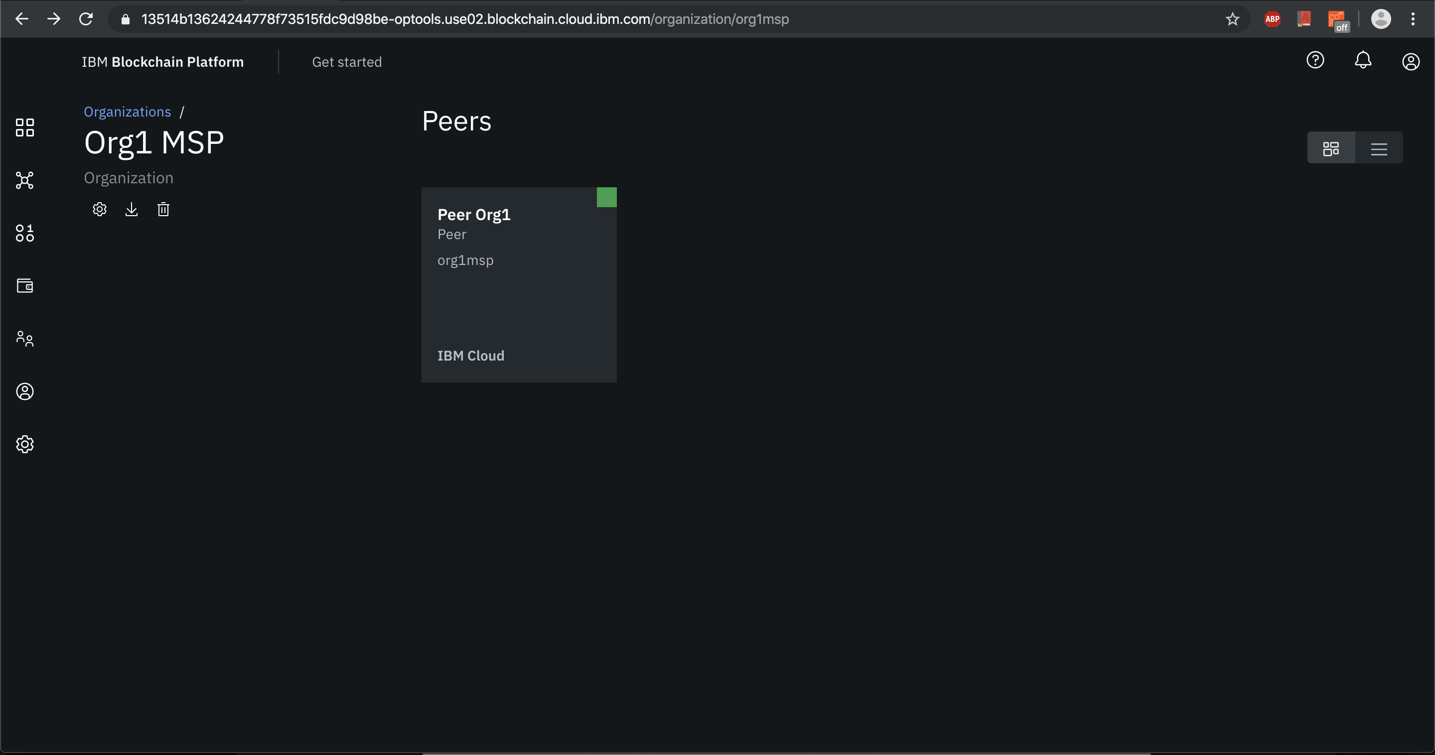

* Created the peer organization and associated with a CA which is encapsulated by MSP

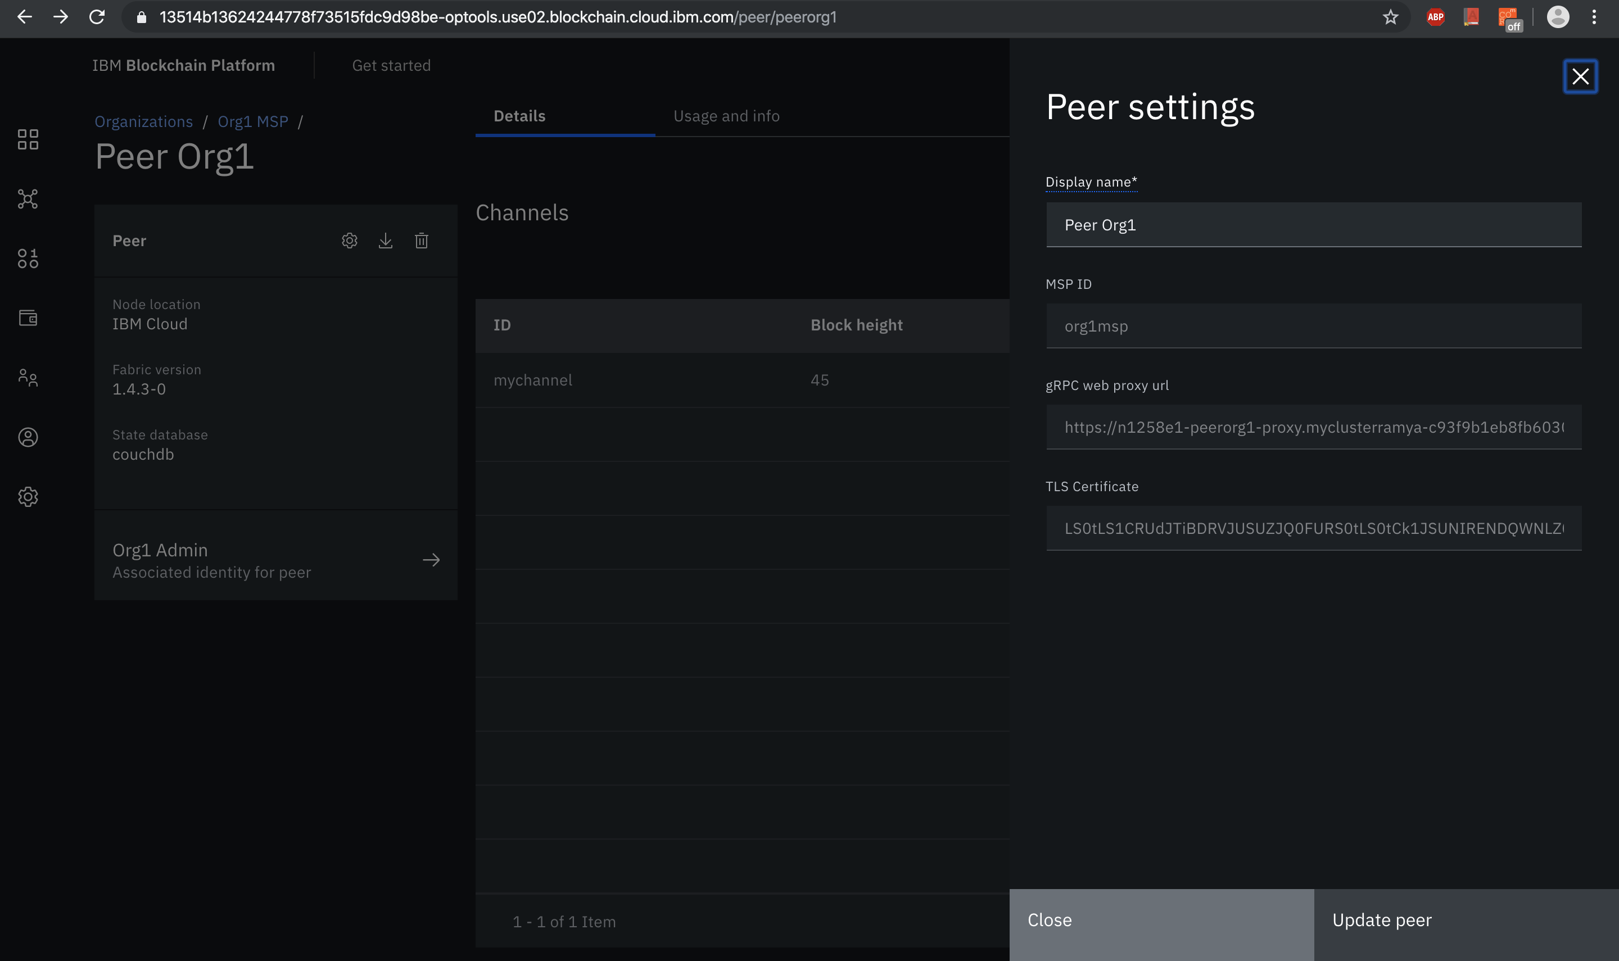

* Created a separate organization – Ordering service. This Ordering service orders blocks of transactions that are sent to peers to be written to ledger and become blockchain.
* Created orderer organization CA

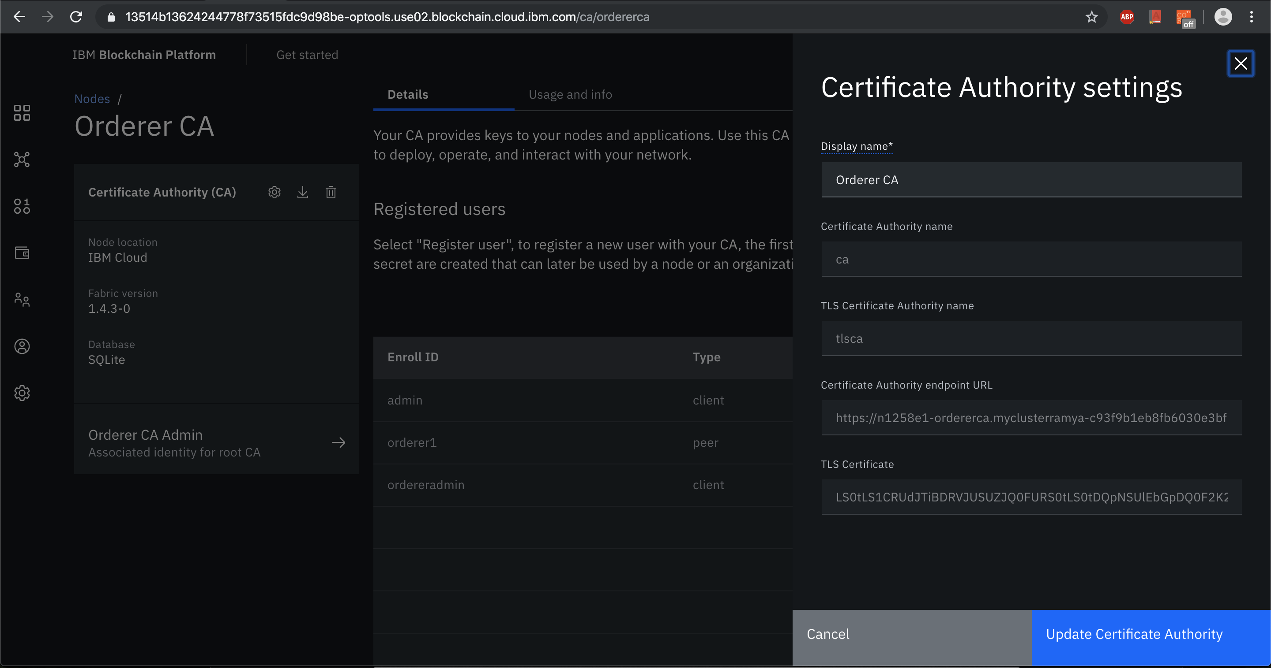

* Using the above CA, registered orderer and orderer admin identities.

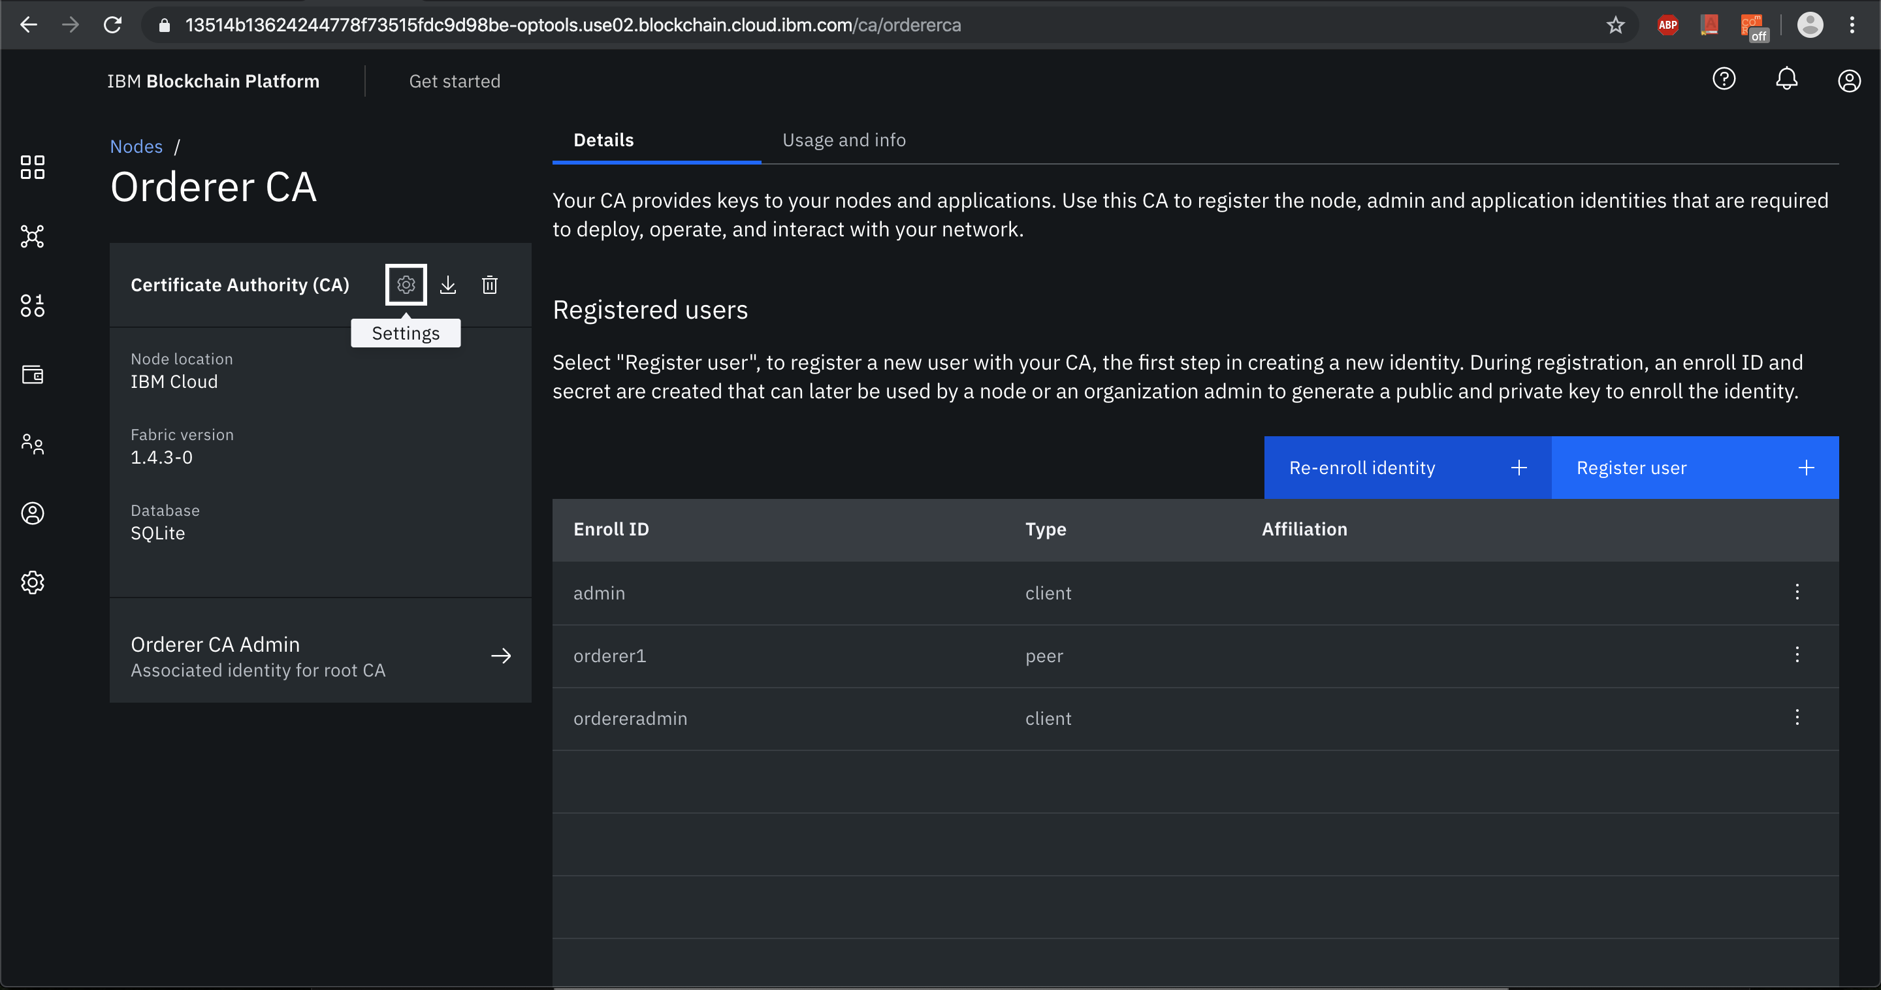

* Created the orderer organization MSP definition

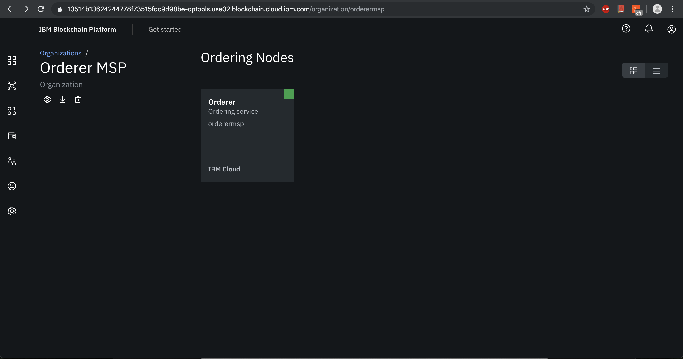

* Created an Orderer

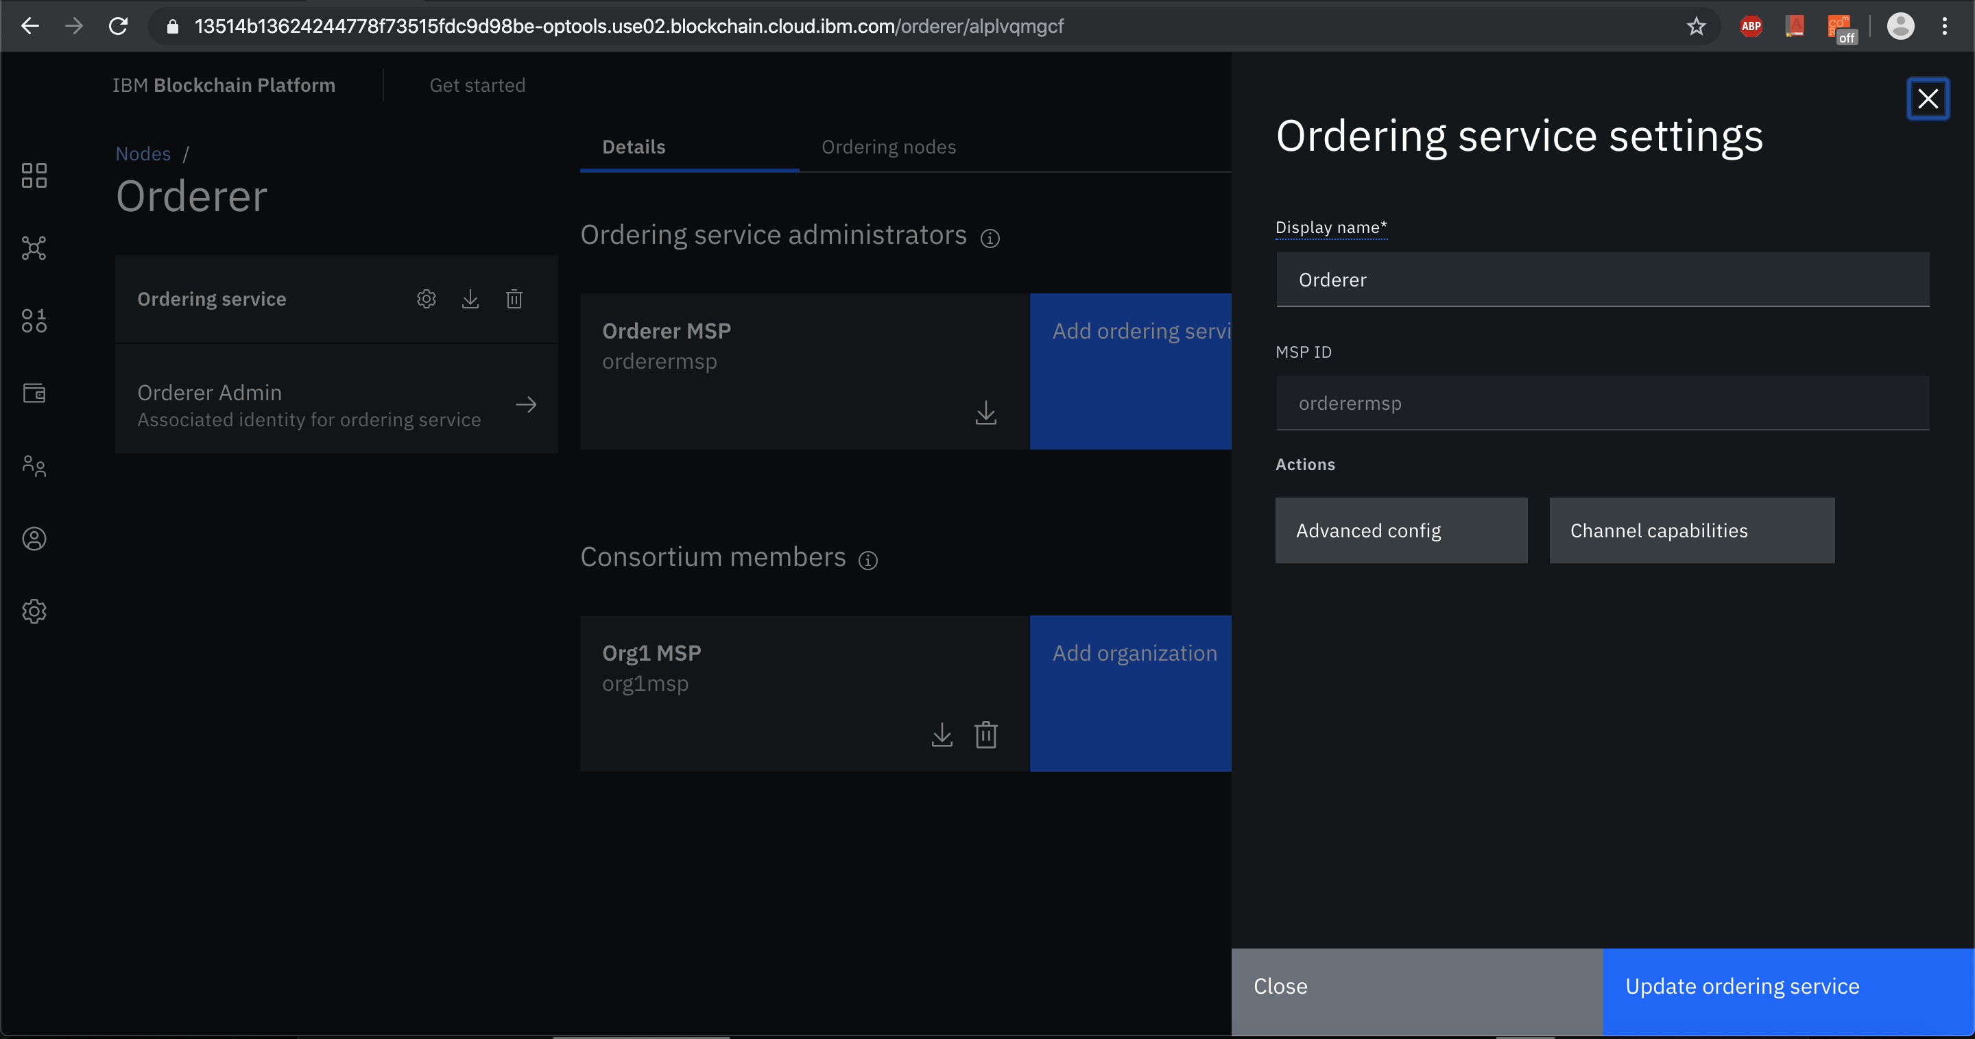

* Added organization as Consortium Member on the orderer to transact

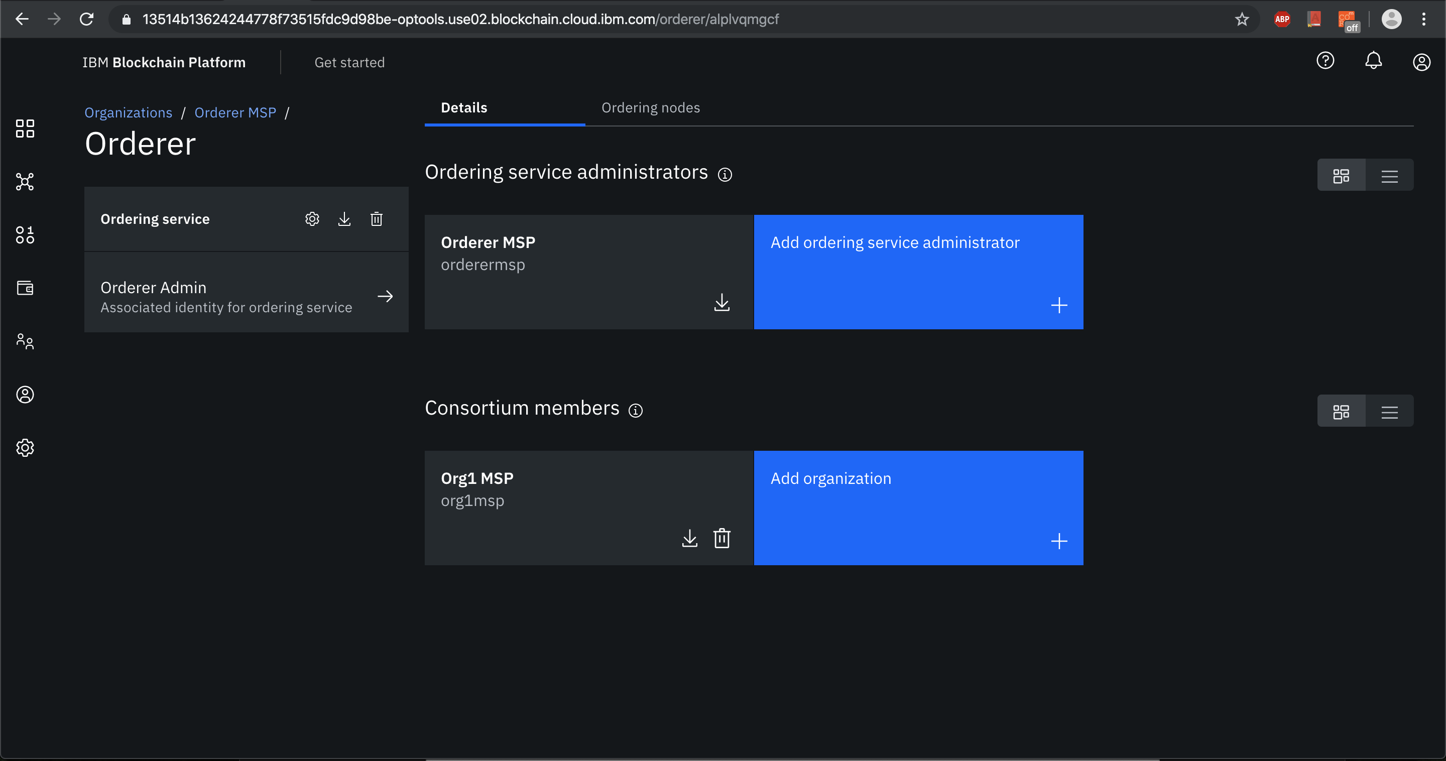

* Created a channel and made my organization as Operator

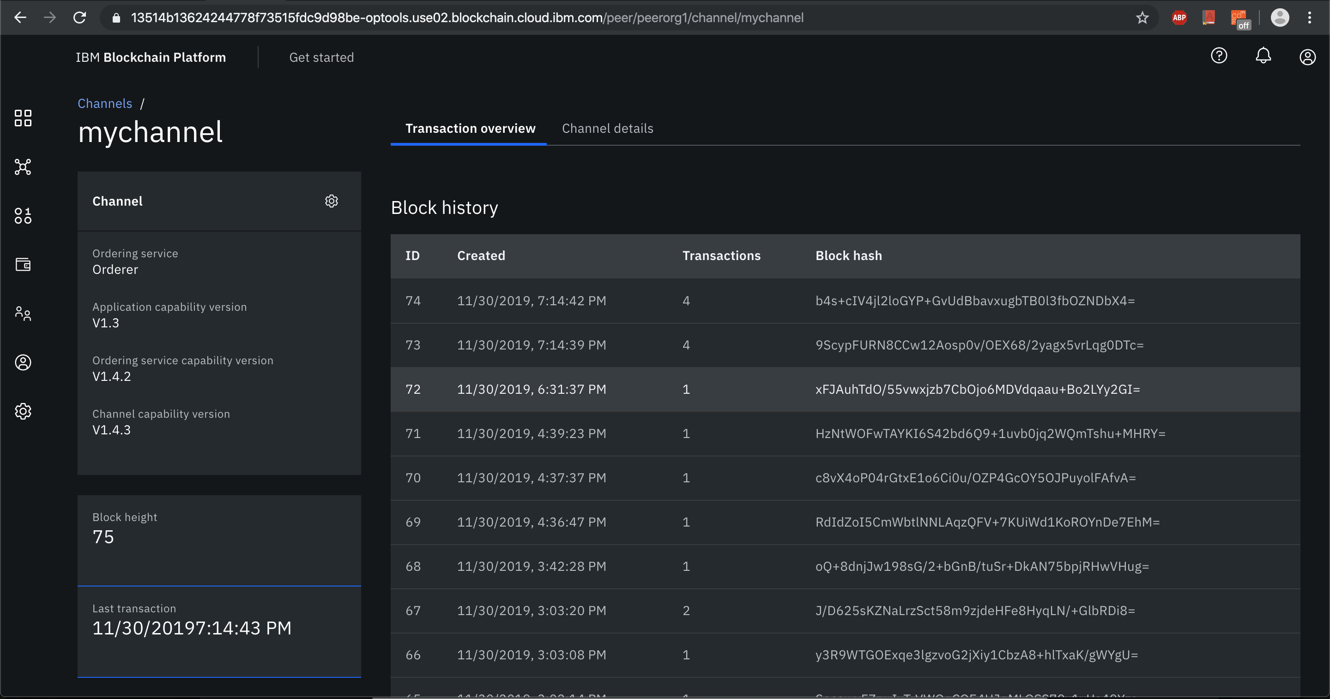

* Joined peer organizations to the channel

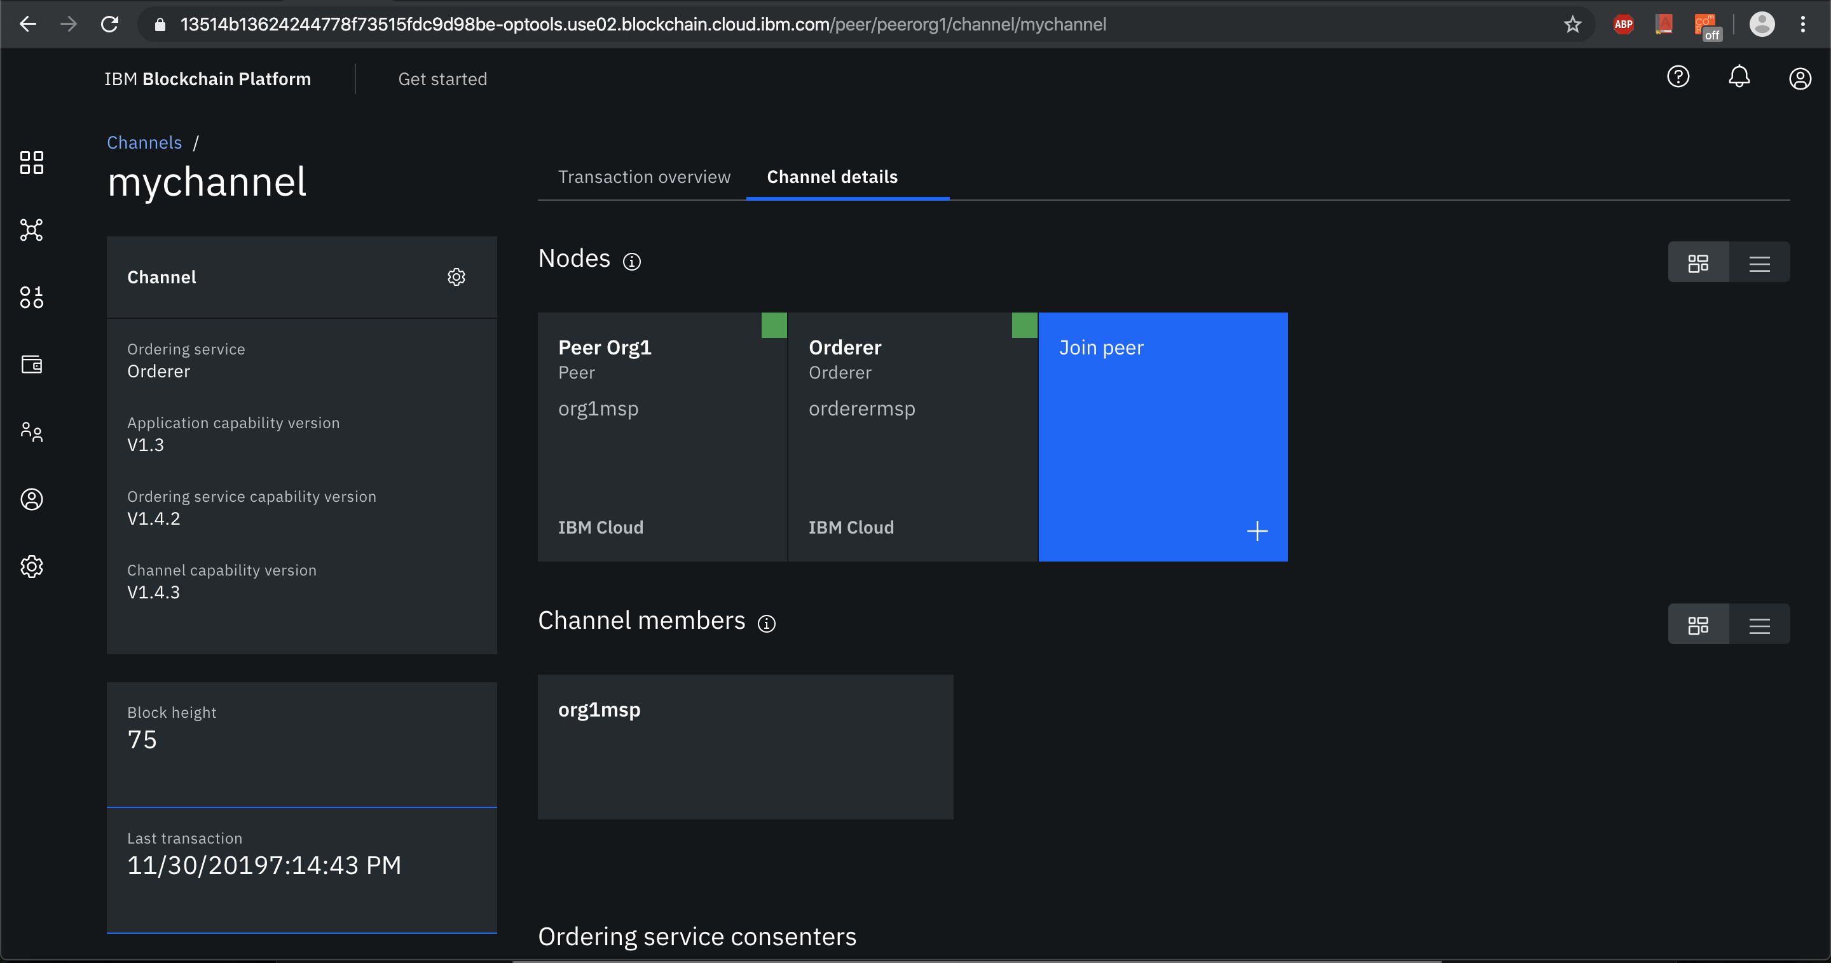

* Deployed FabAgriFund Smart Contract on the network following the below steps.
* Installed the smart contract that was packaged using the Visual Studio code extension.

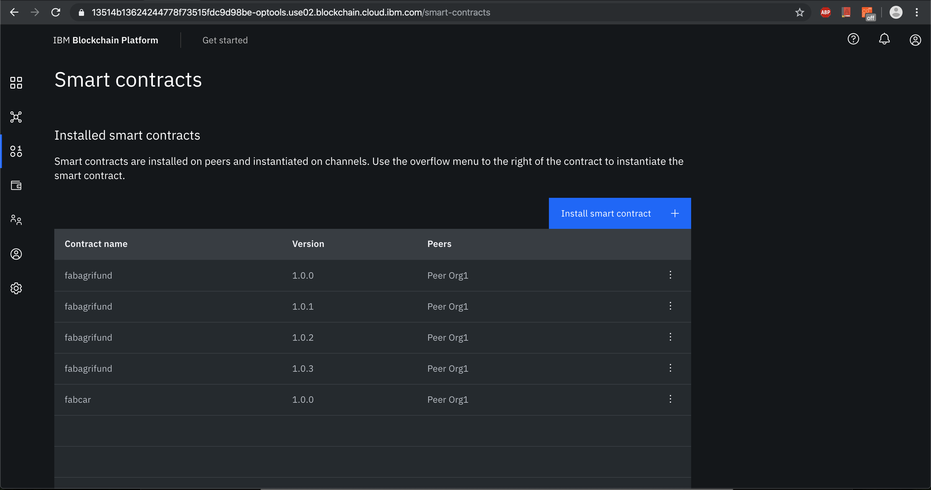

* Instantiated the smart contract from the the list installed on peers.

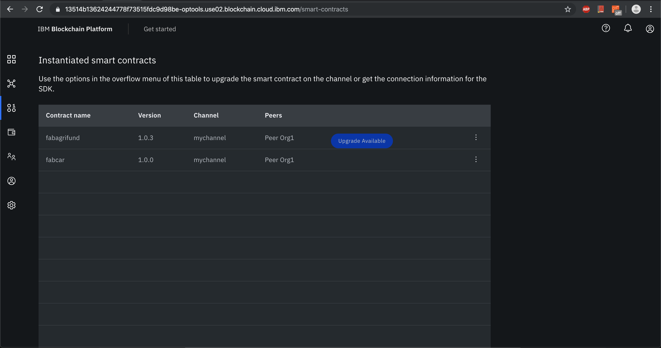

* To connect with SDK, download the connection profile file

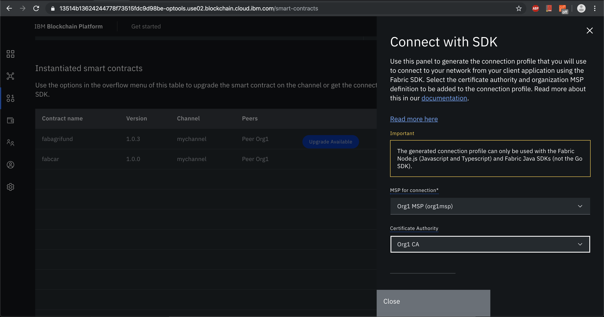

* Created an application admin and registered him as user. App-admin act as registrar and issues identities to the app.

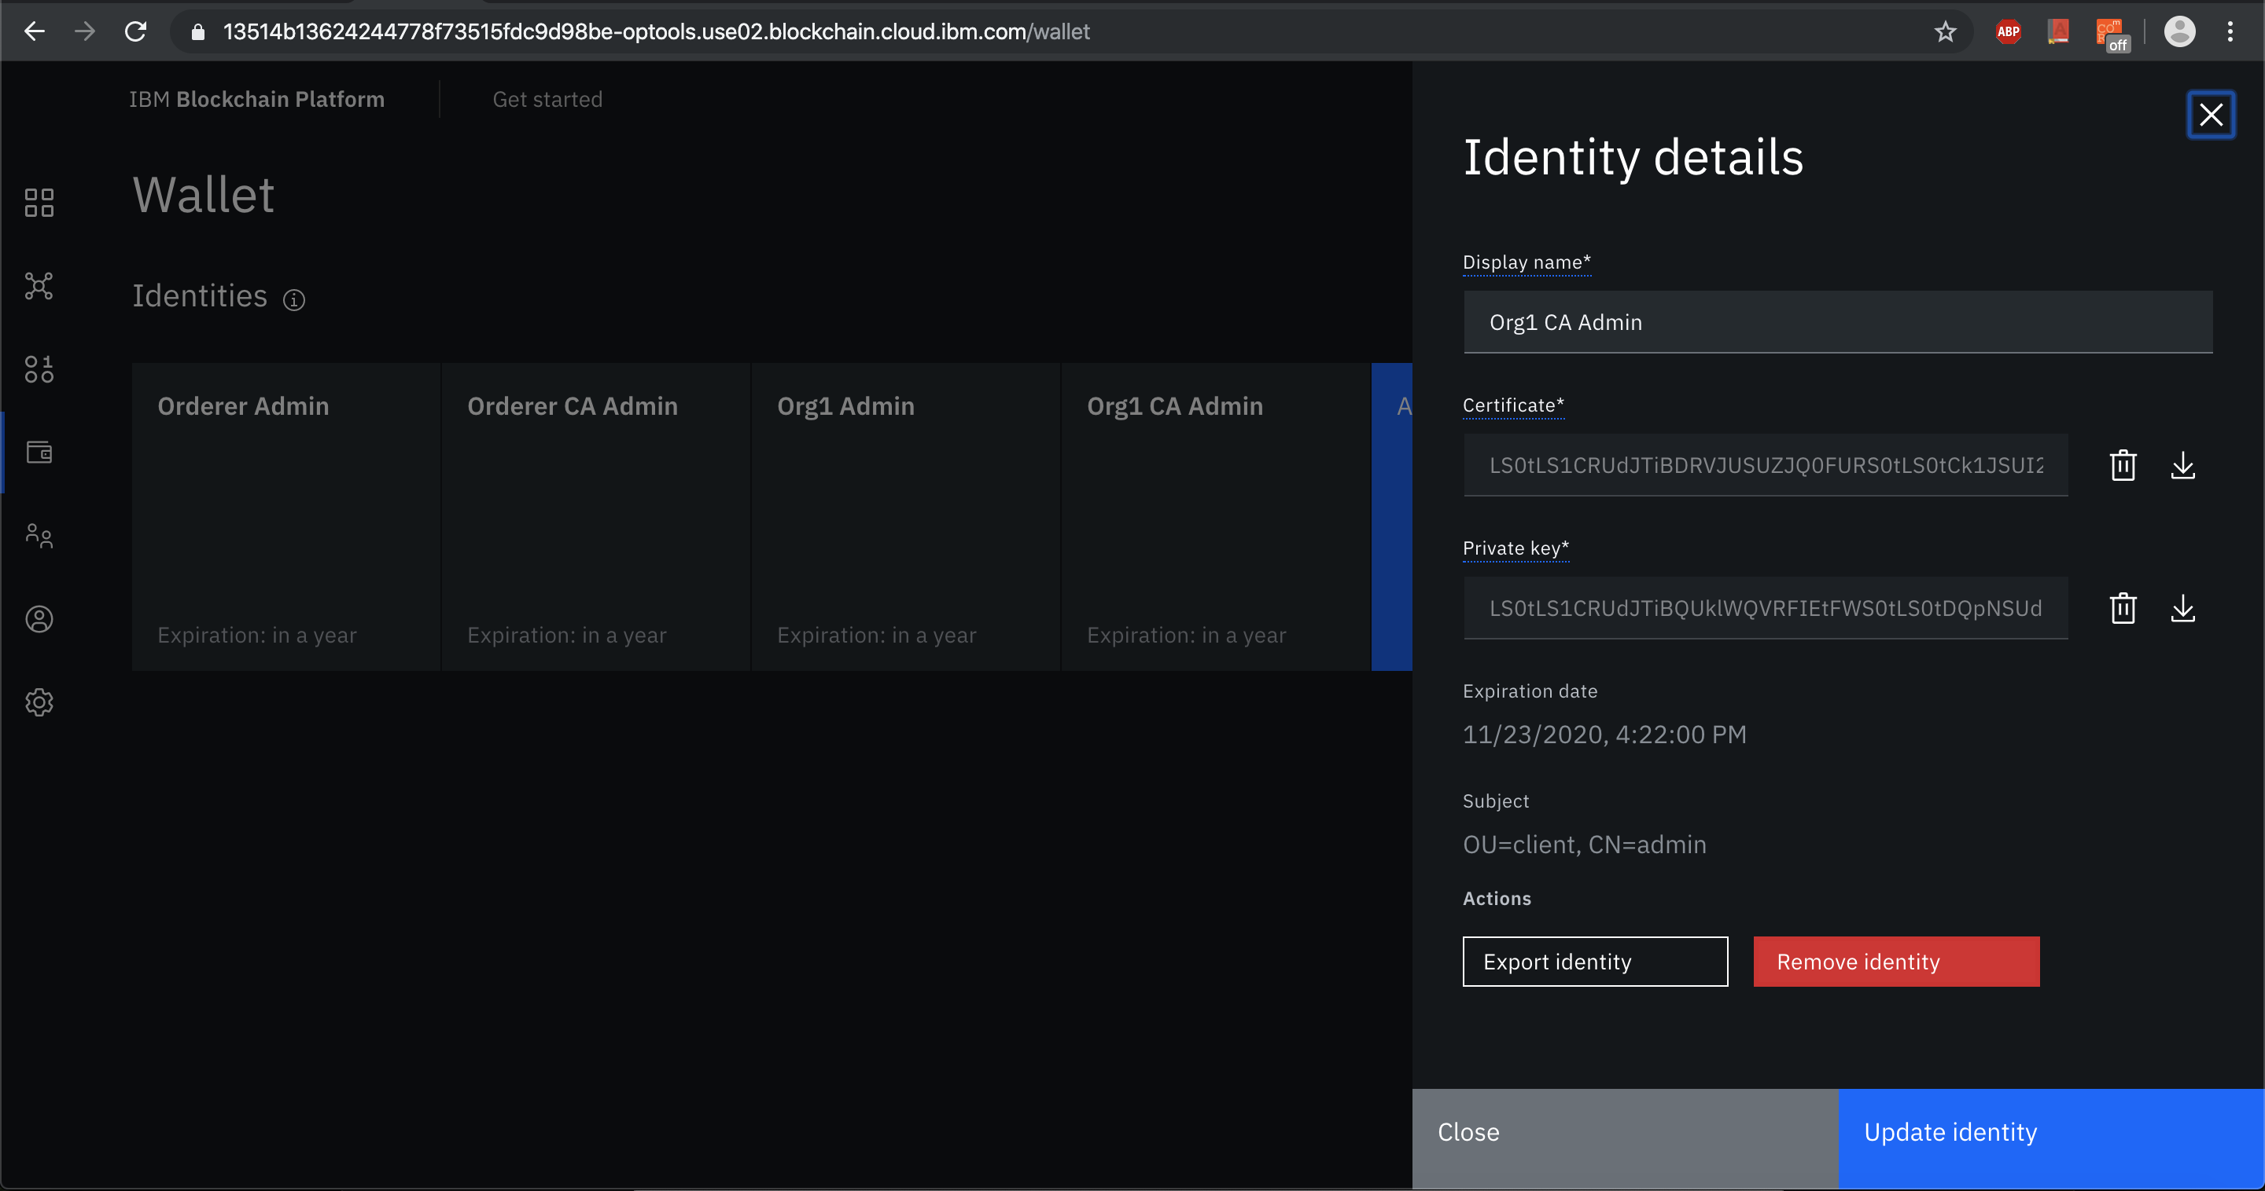

* Copied the connection profile that was downloaded earlier into the server folder and updated the config.json file details

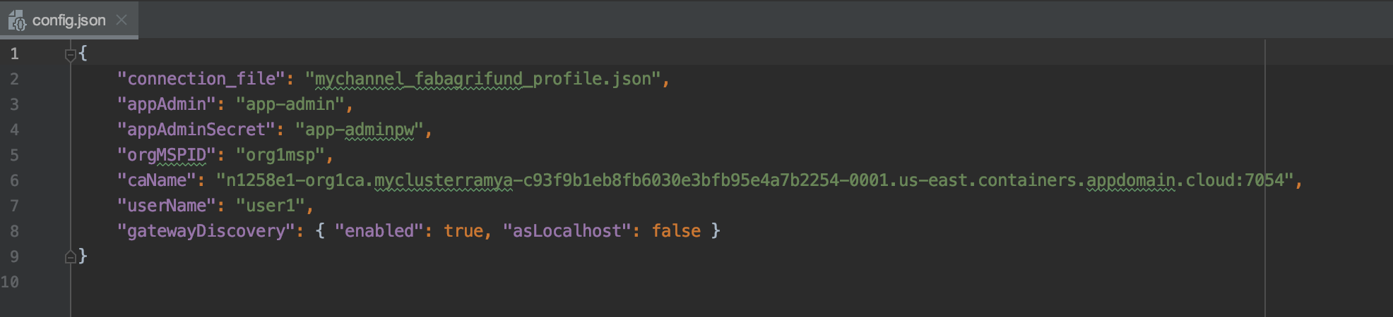

* After installing the node dependencies, enroll the admin using enrollAdmin.js script and register user using the registerUser.js script
* After starting and running the application, we can go to the IBM Blockchain Platform console to monitor the users and get information on our channel including the blocks added.

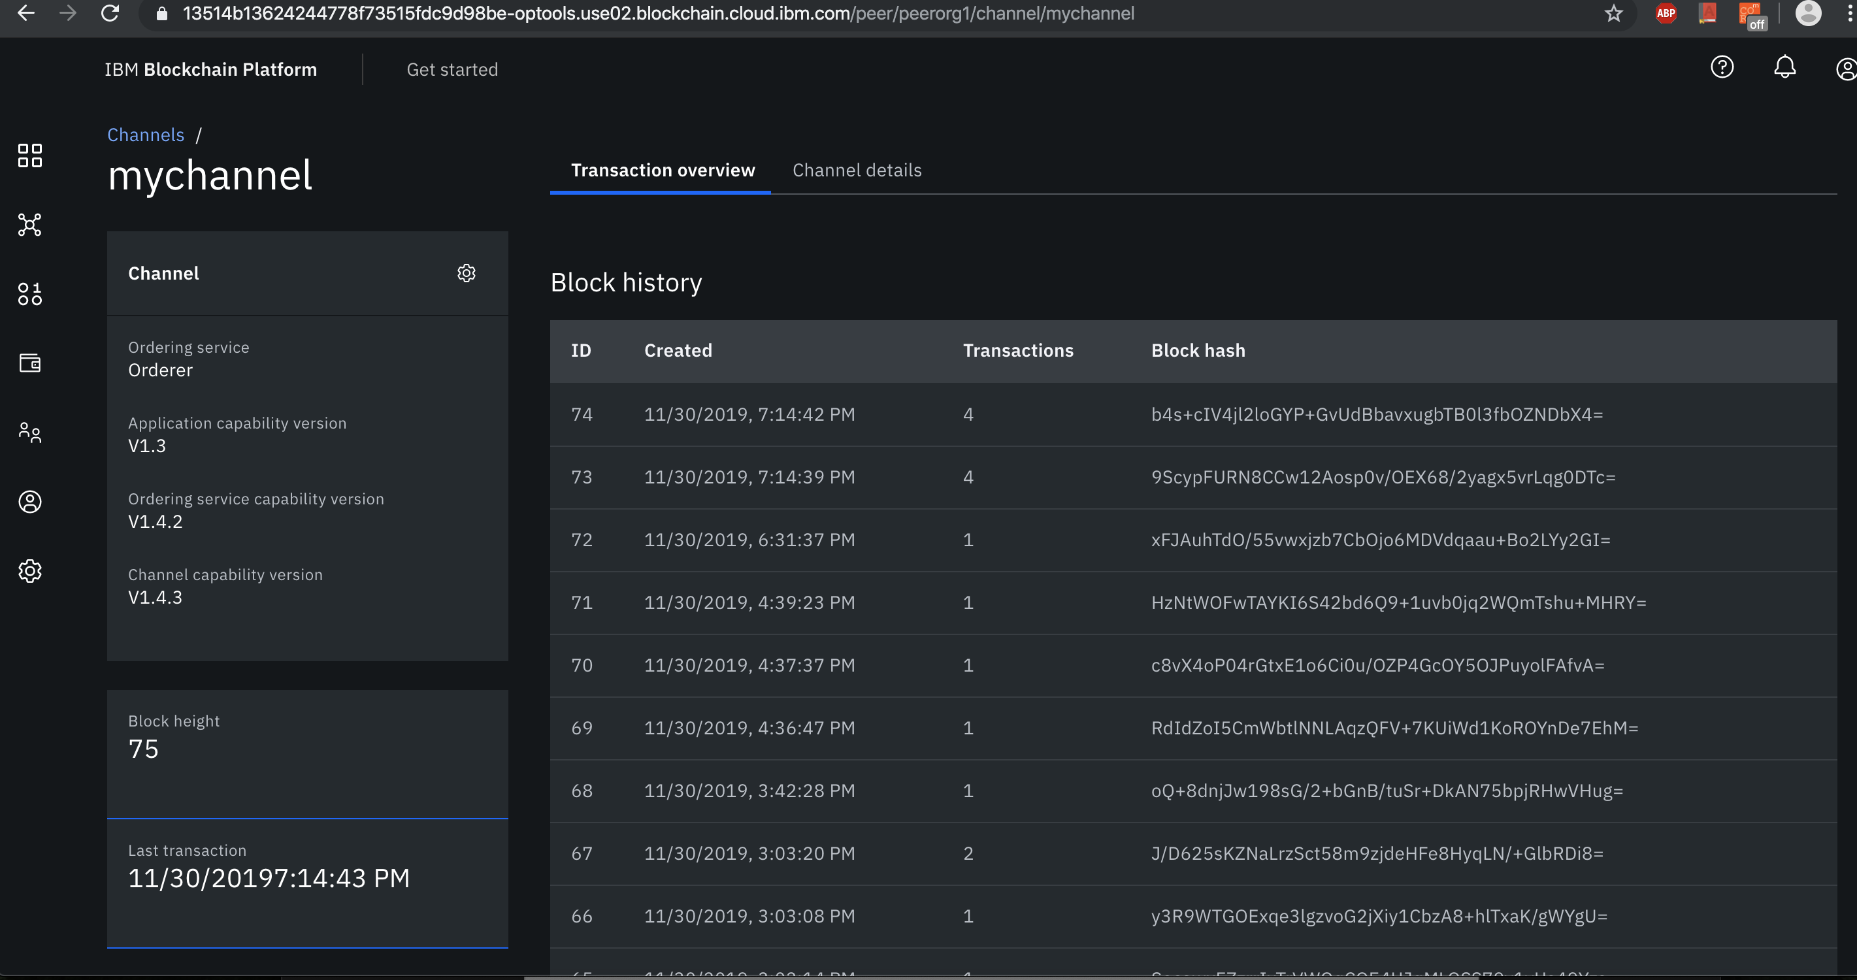

* When a user(farmer or donor) signups to the application, an api call is made so that,he will be registered as a user to the IBM blockchain platform.

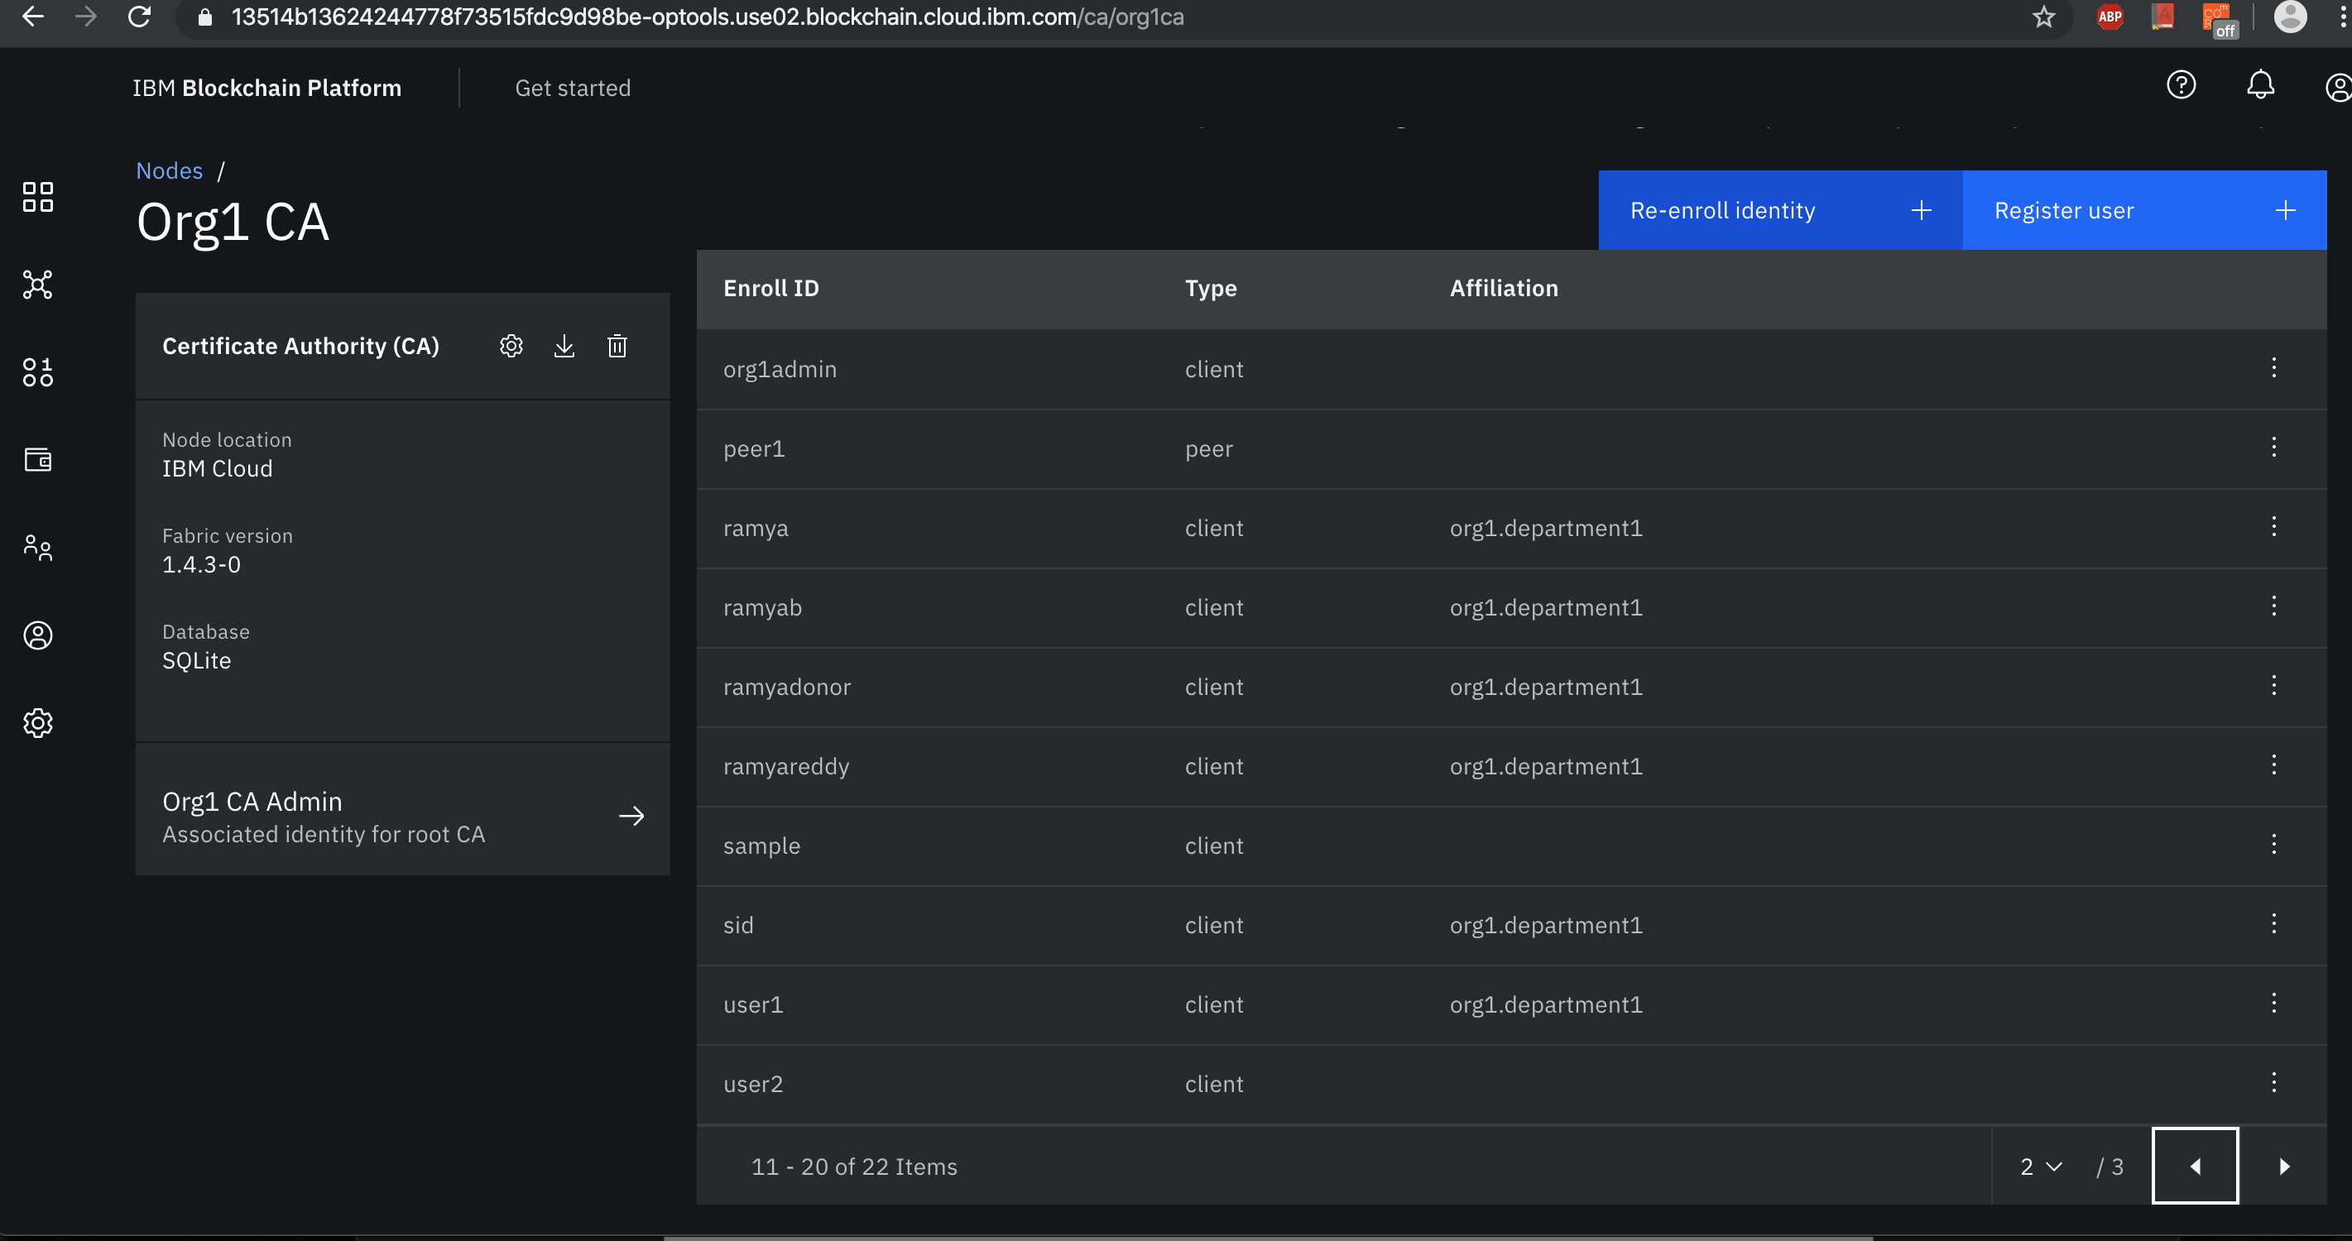

* Whenever farmer adds a problem or edits his exiting problem or closes his problem or whenever a donor adds donation to a problem, a new transaction is submitted to the blockchain. All these transaction submissions are added as blocks to the blockchain.

